Stages:
- Install
- Recieve and input license key
- Setting path for saving handhistory in poker room and start setting up the poker room
- Setting path for search and saving converted hands
- Configure poker manager:
  - Configure Holdem Manager 1
  - Configure Holdem Manager 2
  - Configure PokerTracker
- Setting the desired HUD in converter
- Periodic cleaning old files
- HUD doubling for some skins
- HUD in tournaments and SNG

- Installation
Download the distribution kit from this website http://kingshands.com/soft/24/ click on the button “Download”. Keep the download and launch it. Following the instructions of the installation master, setup the program (to install with default settings push the "Next" button). After the installation you can see the shortcuts of program on your desktop and in the "Start" menu.

- Licensing

After the installation you must launch the program. The program will show a window of license key after the first launch.
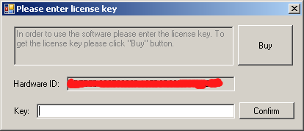
Copy “Hardware ID” value and send it into the Skype kings.hands, and also tell your email (for the account creation purposes). When the payment is received technical support will generate and send you a key, which you must enter in the field «Key» and click «Confirm».

- Configuring the pokerroom
To enable the HUD in Windows 7 and 8, your must also configure launching of the poker application under “Administrator”. You must rightclick the poker room shortcut, then select "Properties" menu item, in properties window, you must select the tab "Compatibility" and set a checkbox on the item "Run this program as an administrator".

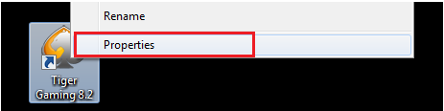
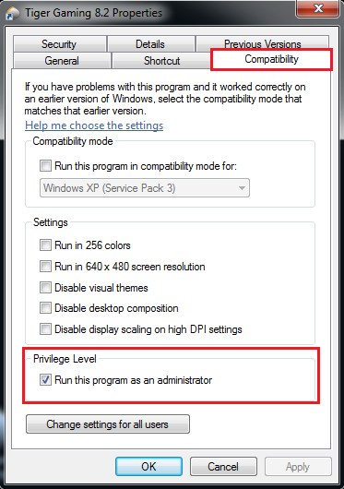
- Configuring the paths in the converter:
On first launch of converter it will search for klaas client if it woun't find it or you delete it you need to do following
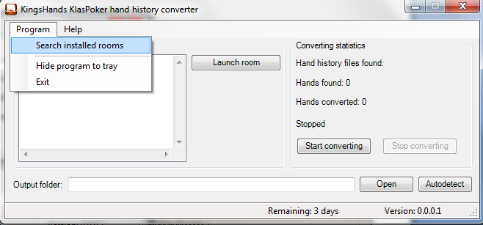

Next, you should create a folder where the converter saves the converted files.
After this folder is created, you should set this path in the editbox "Output folder". To do this, you should click “Open”
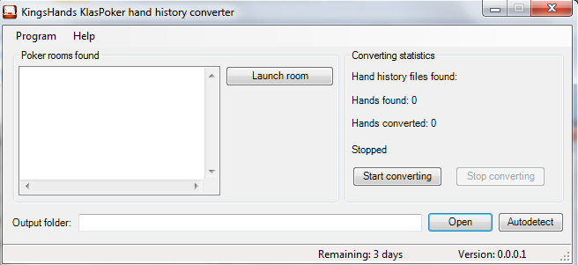
And in the dialog window, you must select the path to the folder.

You need to launch room from converter by pressing "Launch room" button

- Configuration of Holdem Manager1
Launch the manager, then in the main window you should go to "Import" and click a hyperlink «Click here to add autoimport folders».
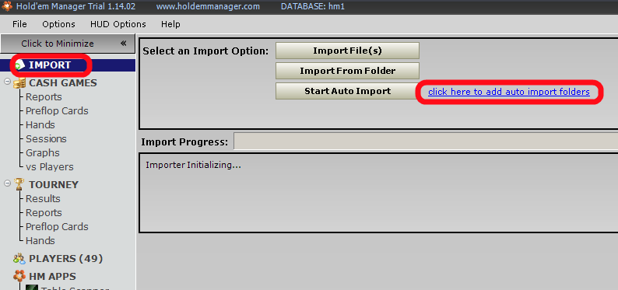
In the opened window, you should click «Add Folder», than there will open an adding window. Press «Select» as it shows in the picture, and set the path to folder you created before for converted files, and then press «Save».
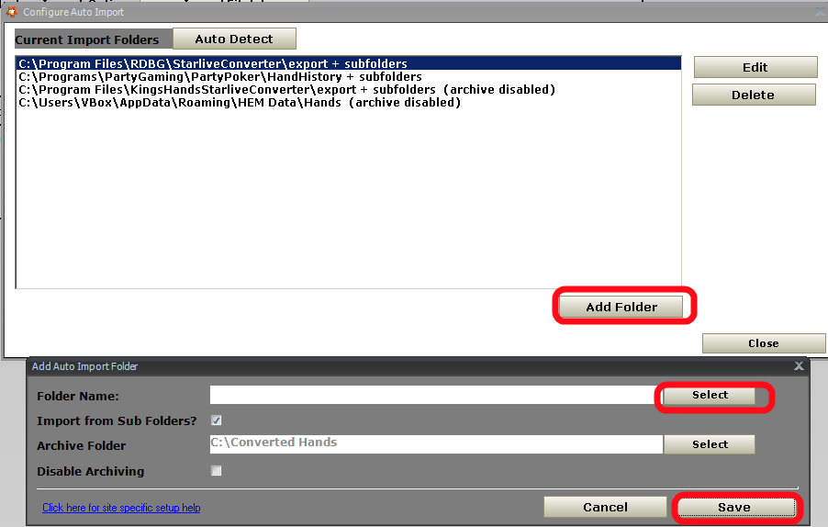
Next, you should press the button «Start auto import» in the manager, and in converter you should push the button "Start", and play few hands. After this, you should use Table Finder only once, Table Finder will offer to add you the name of an executable file (for example, TigerGaming.exe) to your list, and you should agree. After that HUD will find all the tables automatically.

- B) Holdem Manager 2 configuration
Launch the HoldemManager2 and on tab «Home» select «Site setup».
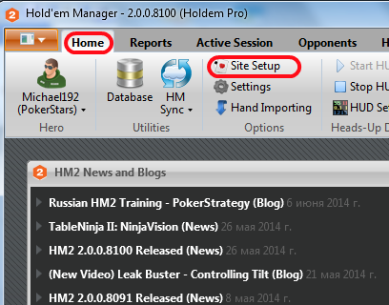

In the Setting window, select the item «PokerStars» and then press the "+" to add a new path

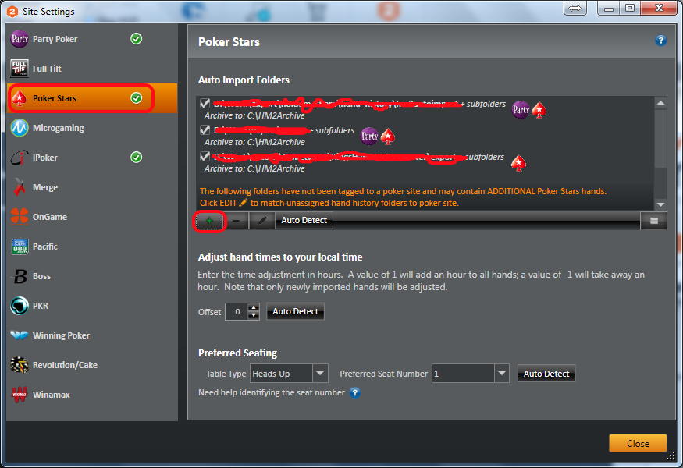

and select the folder where the converter saves the converted files

5.C) The configuration of Poker Tracker

Launch the PokerTracker, click on the tab "Play Poker", in the left side of the list click «Configure», in the opened configuration dialog window select the tab "Site Configuration", then in the list of poker rooms select the PokerStars, click «Add», and select the path where the converter saves the converted files.

If hand converting in PokerTracker was started when you changed the configuration - it must be restarted to apply changes.

