Stages:
- Install
- Recieve and input license key
- Setting path for saving handhistory in poker room and start setting up the poker room
- Setting path for search and saving converted hands
- Configure poker manager:
  - Configure Holdem Manager 1
  - Configure Holdem Manager 2
  - Configure PokerTracker
- Setting the desired HUD in converter
- Options of backup

- Installation
Download the distribution kit from this website http://kingshands.com/soft/1/ click on the button “Download”. Keep the download and launch it. Following the instructions of the installation master, setup the program (to install with default settings push the "Next" button). After the installation you can see the shortcuts of program on your desktop and in the "Start" menu.

- Licensing
After the installation you must launch the program. The program will show a window of license key after the first launch.
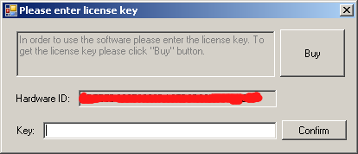
Copy “Hardware ID” value and send it into the Skype kings.hands, and also tell your email (for the account creation purposes). When the payment is received technical support will generate and send you a key, which you must enter in the field «Key» and click «Confirm».
- Configuring the pokerroom
If your install pokerroom Enet, by default HandHistory will be store in C:\Users\username\AppData\Roaming\PokerSunrise\History and your can not change the folder to save hands.

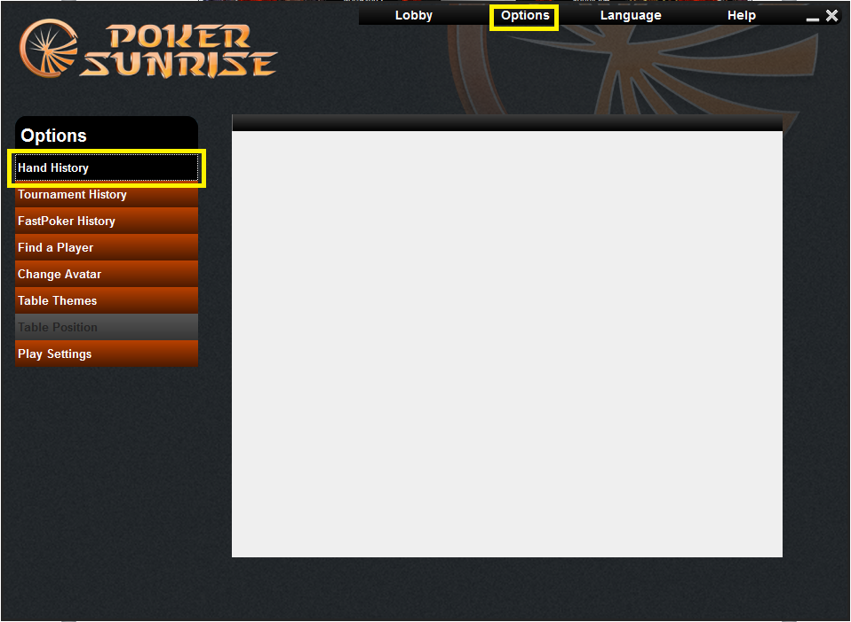
To enable the HUD in Windows 7 and 8, your must also configure launching of the poker application under “Administrator”. You must rightclick the poker room shortcut, then select "Properties" menu item, in properties window, you must select the tab "Compatibility" and set a checkbox on the item "Run this program as an administrator".

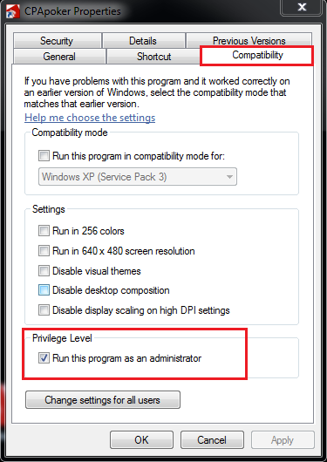
- Configuring the paths in the converter:
In the converter you should push on the “Options”, next you must press “Add folder” button and set the path of the folder, in which poker room save the handhistory. And also you can use «Scan for installed poker clients» button and tool automated will search all pokerrooms of this network.
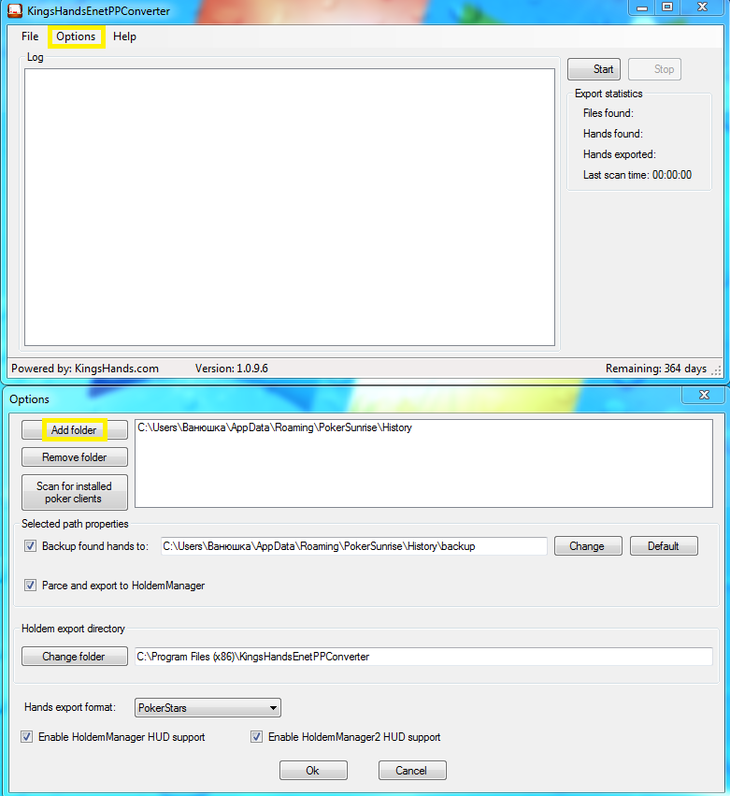
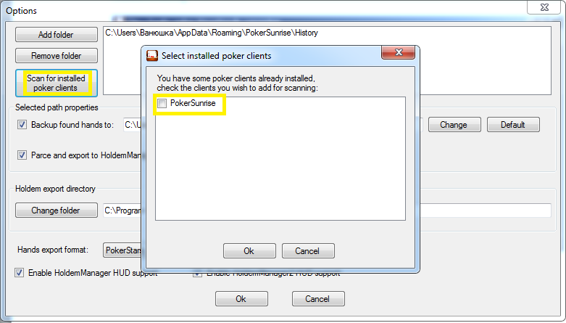
And select the path to this folder for saving hands.
Next, you should create a folder where the converter saves the converted files.
!!!The folder where the room saves the hands and the folder where the converter keeps hands must be different, and one of them must not include other one!!!
After this folder is created, you should set this path in the editbox "Export To". To do this, you should click “...”
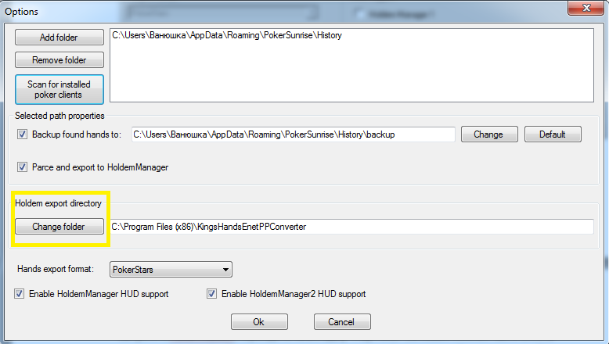
- Configuration of Holdem Manager1
Launch the manager, then in the main window you should go to "Import" and click a hyperlink «Click here to add autoimport folders».
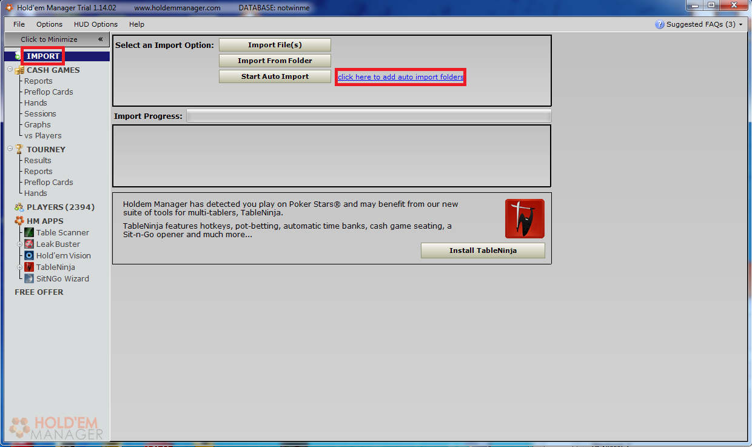
In the opened window, you should click «Add Folder», than there will open an adding window. Press «Select» as it shows in the picture, and set the path to folder you created before for converted files, and then press «Save».
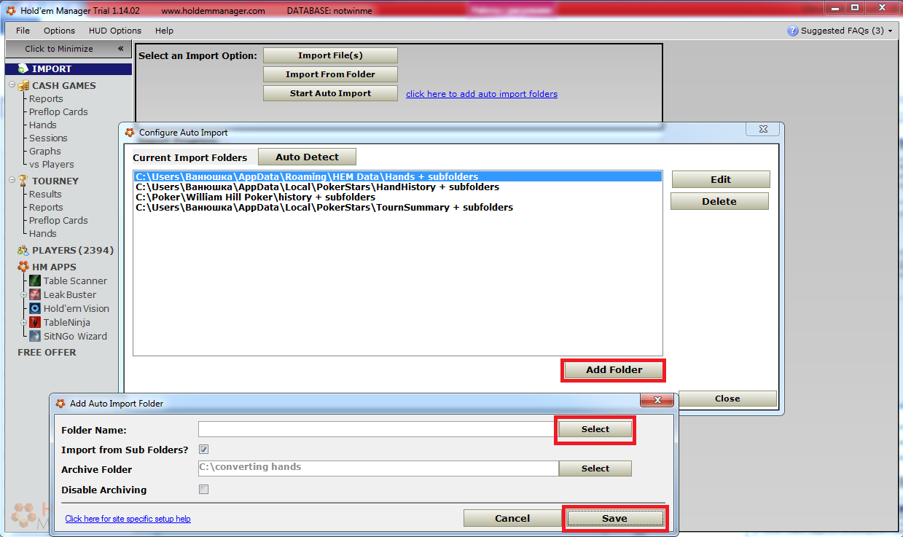
Next, you should press the button «Start auto import» in the manager, and in converter you should push the button "Start", and play few hands. After this, you should use Table Finder only once, Table Finder will offer to add you the name of an executable file (for example, TigerGaming.exe) to your list, and you should agree. After that HUD will find all the tables automatically.
- B) Holdem Manager 2 configuration
Launch the HoldemManager2 and on tab «Home» select «Site setup».
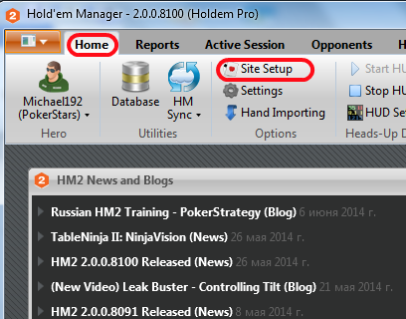
In the Setting window, select the item «PokerStars» and then press the "+" to add a new path
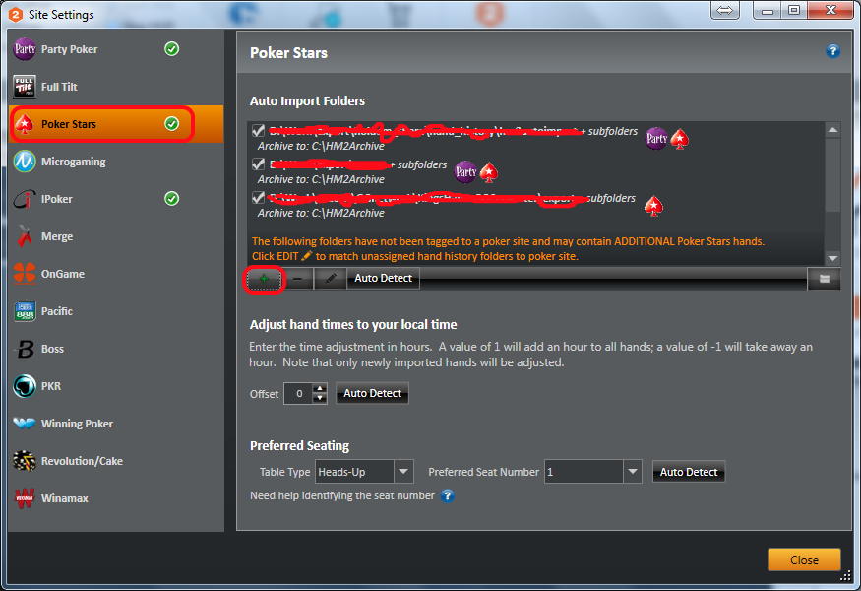
and select the folder where the converter saves the converted files
5.C) The configuration of Poker Tracker
Launch the PokerTracker, click on the tab "Play Poker", in the left side of the list click «Configure», in the opened configuration dialog window select the tab "Site Configuration", then in the list of poker rooms select the PokerStars, click «Add», and select the path where the converter saves the converted files.

If hand converting in PokerTracker was started when you changed the configuration - it must be restarted to apply changes.
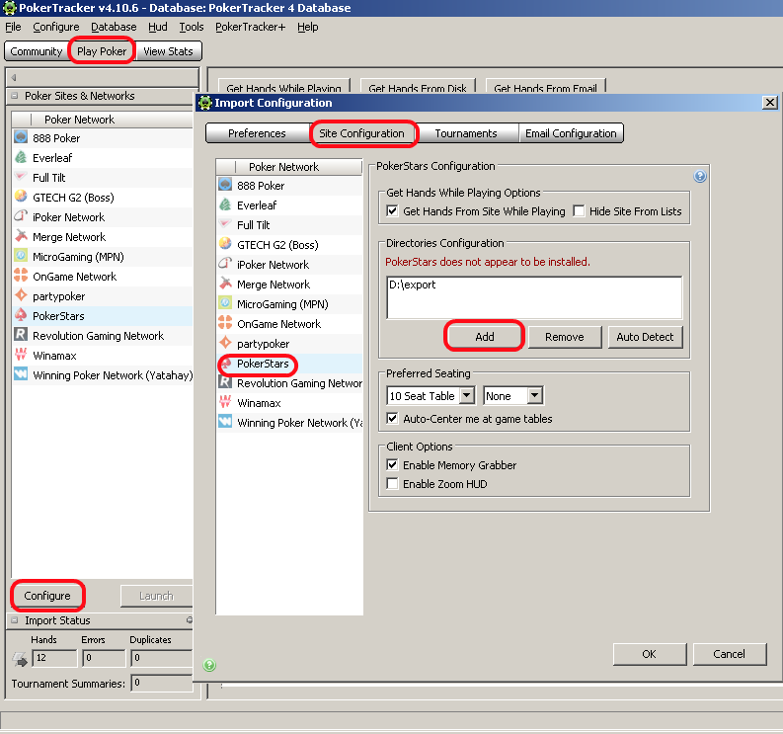

- Setting up the HUD in converter.
It is done by checking the one of the checkboxes, depending on the manager you are using - "Holdem Manager 1" or "Holdem Manager 2 \ Poker Tracker":
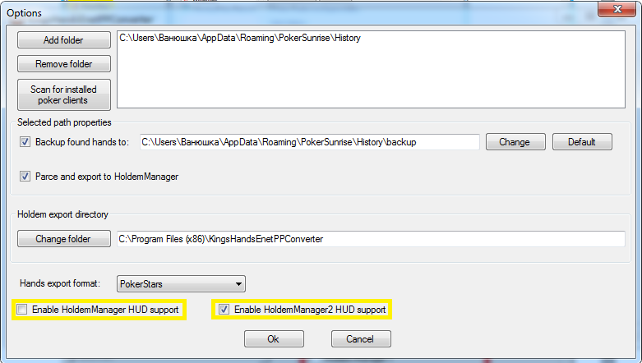

- Options of backup

By default the converter will be converts and deletes the original files, if you put a tick on “backup found hands to” and select the path to save in separate folder for this pokerroom, then the converter will keep the original files in the specified folder.

